# 

RASD

September 6, 2024

Group Members: Antonio Aslan Suarez, Felipe Cano Buitrgo

**1. Introduction 2**

1.1 Purpose 2

1.2 Scope 2

1.2.1 World Phenomena 2

1.2.1 Goals 3

1.3 Acronyms and Abbreviations 4

1.4 Reference Documents 4

1.5 Document structure 4

**2. Overall description 6**

2.1 Product Perspective 6

2.1.1 Scenarios 6

2.1.2 Class Diagrams 8

2.1.3 Statecharts 10

2.2 Product Functions 12

In this section of the document, the main functionalities of LogiHR software will be presented. 12

2.2.1 Inventory management 12

2.2.2 HR management 12

2.2.3 Email integration 12

2.2.4 Data Export 12

2.3 User characteristics 12

2.3.1 Manager User 12

2.3.2 Admin User 12

2.4 Assumptions, dependencies and constraints 13

2.4.1 Domain assumptions 13

**3 Specific Requirements 14**

3.1 External Interface Requirements 14

3.1.1 User Interfaces 14

3.1.2 Hardware Interface 14

3.1.3 Communication Interface 14

3.2 Functional Requirements 15

3.2.3 Use cases 15

3.2.4 Sequence Diagram 19

3.2.5 Mapping on Requirements 24

3.3 Performance Requirements 24

3.4 Design constraints 24

3.5 Software system attributes 24

3.5.1 Reliability 24

3.5.2 Availability 25

3.5.3 Security 25

**4 DataBase Management. 26**

4.1 Database Overview 26

1. Admin_Info: 26

2. Manager_Info: 26

3. RawMaterialInfo: 27

4. FinishedProductInfo: 28

4.2 DataBase Instructions. 29

**5 Effort Spent 31**

**6 References 32**

# Introduction

## 1.1 Purpose

Over the past couple of decades, independent and small and medium size apparel businesses (AB) have started to appear which mainly operate on the internet. This increase has been due to the reduction in the entry price as now there is no need for stores, expensive marketing campaigns (take influencer apparel as an example) and other operational costs. For this reason, the need for a software that fuses both warehouse management and HR software that can be used for small and medium scale operations has appeared, this is due to the current solutions in the market being only applicable to large-scale business.

Considering all of these factors, a new warehouse and HR management software called LogiHR has been created, which aims to be an all-in-one (AiO) solution for small and medium-sized AB.

The purpose of this document is to define the goals and requirements of the LogiHR software, together with the structure and interaction between its different components.

## 1.2 Scope

To define the scope of the project and the requirements it shall have, a series of world phenomena that may affect a small or medium-sized apparel business will be considered.

### 1.2.1 World Phenomena

| **Identifier** | **World Phenomena** |
| --- | --- |
| WP1 | AB have inventories to keep track of |
| WP2 | AB have to generate invoices for purchase orders |
| WP3 | AB have to email invoices to other businesses or departments inside of the same company |
| WP4 | AB needs to search for the current stock of certain items |
| WP5 | HR save relevant information of employees, whose information may be updated in the future |
| WP6 | HR may add or delete employee information depending on the current status of said employee |
| WP7 | AB generates invoices for outgoing shipments |
| WP8 | AB need to analyze the historic data of their stock |
| WP9 | AB use DS or ML techniques to determine stock for every quarter |
| WP10 | Accounting needs to have historic data of the volume in $ of the stock |

### 1.2.1 Goals

| Goal | Description |
| --- | --- |
| G1 | Provide a platform for managing warehouse operations, including tracking inventory levels of raw materials and finished products to ensure optimal stock levels |
| G2 | Implement real-time updates for stock levels, with features for generating invoices and processing orders. Managers will be able to inspect stock levels, create orders, and generate invoices when necessary. |
| G3 | Implement email notifications when invoices are generated (raw material purchases, finished products requests, etc). This will make the process of making invoices much more streamlined. |
| G4 | Allow data export capabilities to standard formats like .xml and .cvs for integration with external analysis tools and ML teams. This will facilitate detailed insights into inventory trends, employee performance, and financial records. |
| G5 | Ensure ease of use with a user-friendly interface,which will be a differentiating factor w.r.t competitors. The system should be intuitive and efficient and require little training |
| G6 | Provide HR personnel with a simple solution for employee management and data, such as address, salary, etc. |
| G7 | Every component in the database (DB) shall be searchable and easy to find an keep track of, including materials, finished products and personnel. |

## 1.3 Acronyms and Abbreviations

| **Abbreviation** | **Description** |
| --- | --- |
| WPx | World Phenomena |
| Gx | Goal |
| HR | Human resources |
| ML | Machine Learning |
| w.r.t | with respect to |
| AB | Apparel business |
| DB | Database |
| Dx | Domain assumption |
| UI | User Interface |

## 1.4 Reference Documents

* Feasibility Study
* Uses Cases
* Requirements

## 1.5 Document structure

This document is organized into six sections:

1. **Introduction**: This section outlines the overall purpose, goals, and scope of the *LogiHR* project. It also introduces key terms and abbreviations used throughout the document.
2. **Overall Description**: This part describes the system from a high-level perspective, including the product's environment, user interactions, and its key functions. Diagrams, such as use cases and class diagrams, are used to illustrate the system’s structure and behavior.
3. **Specific Requirements**: This section goes into detail about the system's functional and non-functional requirements. It includes user interface, hardware, and communication requirements, along with use case diagrams and mappings to goals and requirements.
4. **Effort Spent**: The contributions of each team member are detailed here, listing the tasks performed and the time spent on each part of the project.
5. **References**: This section lists all reference materials and documents used in the creation of this RASD, including industry standards and relevant external documents.

# 2. Overall description

## 2.1 Product Perspective

### 2.1.1 Scenarios

1. **Manager inspects current stock of raw material**

Manager wants to know the current stock of raw material Jean buttons to see if there is the need to make the new order. He logs into the system with its user and password and navigates to the raw materials menu, then he searches the required material using the search bar. Once he has the information, he can decide if he wants to make an order for said material or do nothing.

1. **Fulfill order from store with invoice creation**

An order has been made from a store to send 100 basic T-shirts. The manager logs into the system and navigates to the Finished products menu, once it has located the correct product and checks that there is enough stock to satisfy the order, he deducts the stock from the current inventory and generates the invoice with the button Print. Once the invoice is ready he can send it via email using the Send button to [store@store.com](mailto:store@store.com), also the invoice can be sent to [logitics@warehouse.com](mailto:logitics@warehouse.com) so that they can manage the package to be sent to the store. In the end, the final stock is reflected in the inventory and both the store and logistics department have their invoice in their email inbox.

1. **DB export for data analysis**

Upper management is deciding whether or not to increase production of sweaters during Q4 because for the past couple of years, the stock has been depleted. But they still need to decide if it makes financial sense and if such, by how many units shall the production be increased. For this tasks, upper management has selected an external data-analysis team which asks to receive the historic data of the stock and

price of the product and the costs of the raw materials. To achieve this task, an employee with the role of admin shall log into the system and navigate to the admin panel, then the employee can select the Export button and select the correct file format, finally he presses the send button and the data is send to [data@analysis.com](mailto:data@analysis.com).

1. **HR adding a new employee**

After conducting an interview, HR has decided that Giacomo is a good fit for the role of warehouse manager, and after signing the contract, he need a user ID and password to enter the system and start working, also the new employee data shall be added to the database for accounting purposes. The HR employee logs into the system and navigates to the employee section, where he can enter all the relevant data of the new employee and the role (in this case Manager). Once the employee hits save, an ID is generated with the password, so the new employee can log into the system without any problem.

1. **HR changing employee data**

A new warehouse is being opened in Parma, and to run this new branch, HR has decided that former warehouse manager Sara is a good fit for the role of branch manager, a role that also includes selecting new employees. For this reason, HR department logs into the system and navigates to the employee section, here he searches for Sara and updates its details, changing the address to Parma, adding 10k to the yearly salary due to the increased workload and finally the role of the employee is changed to admin. Now, Sara can log into the system using the same ID but with the admin role, making it possible for her to add new employees or modify information.

### 2.1.2 Class Diagrams

The class diagram shown in this chapter provides a deeper look at the key classes within the project, highlighting the system's architecture from a programming standpoint. As the project is developed using a graphical language like C#, the main classes are integrated into graphical user interface (GUI) components. These components, which represent the various forms in the application, are the primary points of interaction for users. All data displayed and manipulated within the system is retrieved and updated via a connection to the underlying database.

**Main Takeaways:**

1. **Form Interaction**: Each form in the system, such as FormLogin, FormAdmin, and FormWarehouseManager, acts as a user interface tailored to specific functionalities. These forms depend on the DataAccess class for handling all database operations like queries, inserts, updates, and deletions.
2. **User Authentication**: The FormLogin class manages user authentication, allowing administrators and warehouse managers to log in. Once authenticated, administrators are directed to the FormAdmin interface, while warehouse managers access FormWarehouseManager.
3. **Employee Management**: FormAdmin is used for handling employee records, such as creating, updating, or deleting employee information, adjusting roles, and managing salaries. It interacts with the database through the DataAccess class to ensure real-time updates.
4. **Inventory Management**: FormWarehouseManager oversees inventory management, including both raw materials and finished products. Users can perform CRUD (Create, Read, Update, Delete) operations on inventory items. It also enables tracking key details like product quantities, costs, and categories, keeping inventory data accurate and current.

The class structure is designed to ensure clear separation of responsibilities, with each form addressing a specific function while relying on a shared data management layer (DataAccess) for efficient and consistent database interactions.

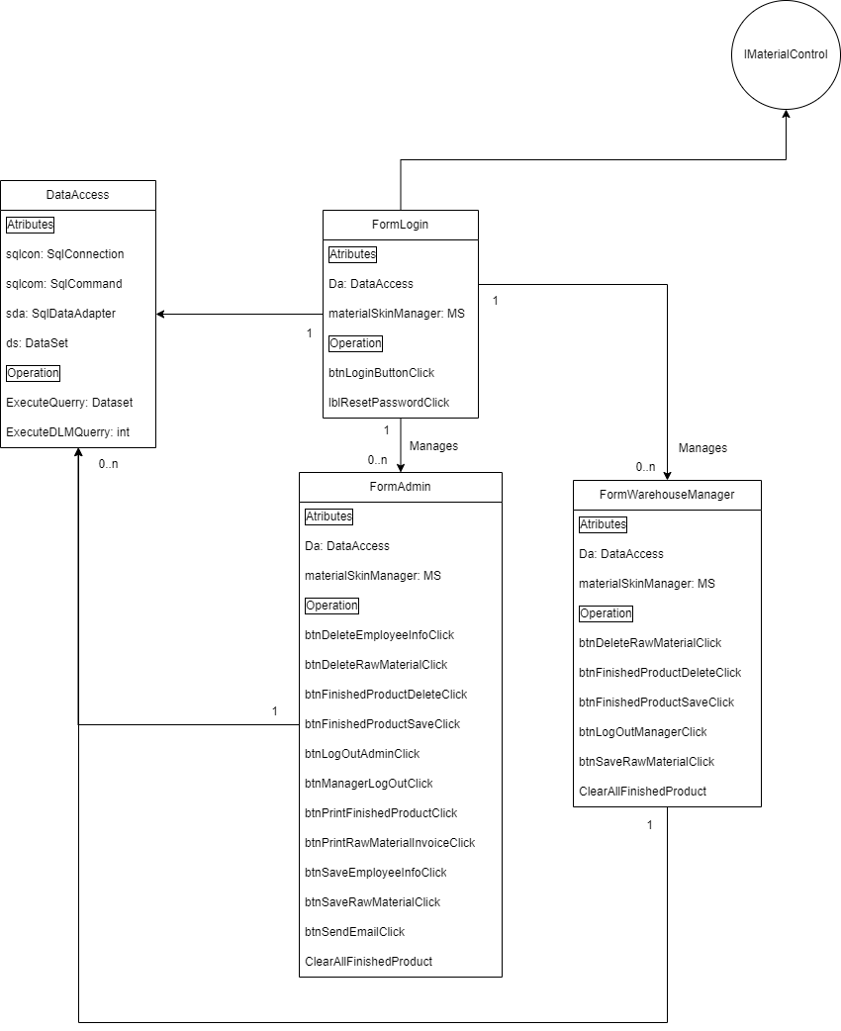

### 2.1.3 Statecharts

In this section some state charts of significant processes of the system are shown. All the processes without a “if” clause are left out due to their redundancy with the use cases.

1. **User login**

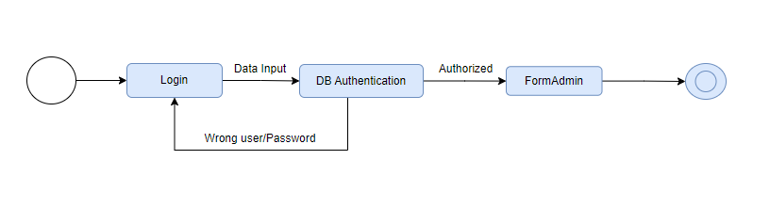

The login process diagram illustrates the path the user follows after pressing the login button. The user's information is sent to the database, which returns the user's access level. Based on this, the program determines whether the user can proceed to the next form.

1. **Save User**

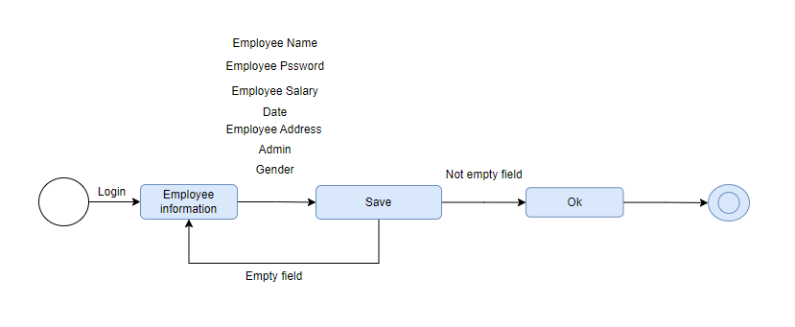

To create a new user, the employee information window must be selected. All the user details need to be filled in, and once the database confirms that the information has been saved, a pop-up window will indicate the success of the process.

1. **Delete User**

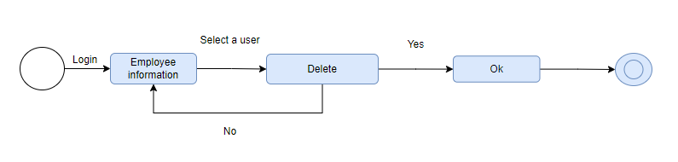

To create a new user, the employee information window must be selected. All the user details need to be filled in, and once the database confirms that the information has been saved, a pop-up window will indicate the success of the process.

1. **Save Material**

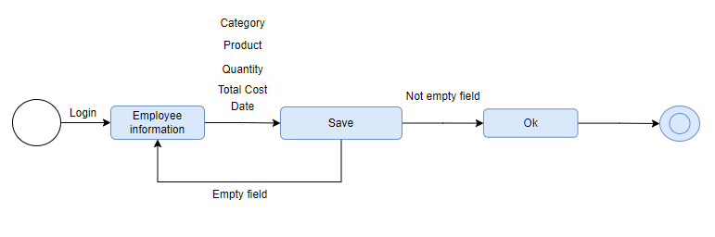

Following the same logic of the user creator it is possible to enter a new material. Checking that all the fields are not empty.

1. **Print Material**

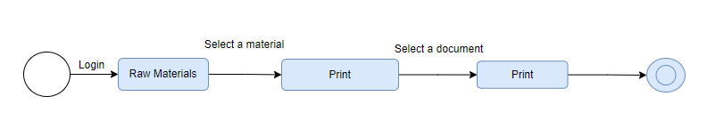

When a product is selected it is possible to print print directly selecting a printer.

## 2.2 Product Functions

## In this section of the document, the main functionalities of LogiHR software will be presented.

### 2.2.1 Inventory management

This is the main functionality and selling point of the software, to be able to keep track of the inventory in a warehouse and generate invoices for purchase orders using a clear and intuitive interface.

### 2.2.2 HR management

Keep in one place all the relevant information about the employees of the business.

### 2.2.3 Email integration

Every time an invoice is generated, the option to send it over email makes the process of forwarding these invoices efficient.

### 2.2.4 Data Export

The db can be exported to .xml for accounting or .cvs for further analysis.

## 2.3 User characteristics

This section of the documents aims to differentiate the different types of users that will use the software, mainly between admin and managers. Due to the simplicity of the UI, it is not required for the users to be trained in the use of the program.

### 2.3.1 Manager User

This role is reserved for warehouse managers, meaning that they are the ones in charge of keeping track of the current inventory, generating invoices, etc. They have privileges to change current stock of products, generate invoices and other functionalities. On the other hand, they do not have privileges to read or change employee data. A manager user is not able to change its role.

### 2.3.2 Admin User

This role is reserved for employees in the HR department and upper management. In addition to all the previous privileges of the manager users, admin users can read or change employee data, such as address or salary. Due to this enormous privilege, the admin role is only reserved for high-trust employees. Admin users can create or upgrade the privilege of other users.

## 2.4 Assumptions, dependencies and constraints

### 2.4.1 Domain assumptions

| Identifier | Domain Assumptions |
| --- | --- |
| D1 | The SQL server shall be correctly put into operation |
| D2 | Every user shall have the latest software version and its login credentials to the SQL server shall be correct |
| D3 | The program shall be connected to the internet to run properly |
| D4 | Admin user shall not exploit the privileges it has w.r.t changing sensitive information of itself and other employees |

# 3 Specific Requirements

## 3.1 External Interface Requirements

### 3.1.1 User Interfaces

1. **Login interface**

The Login Interface for *LogiHR* allows authorized users, such as managers and admins, to securely access the system. Users are prompted to enter their username and password, with an option to recover credentials if forgotten. Upon successful authentication, they are directed to the system’s main dashboard.

1. **Raw Material and Finished Products interface**

Provides a real-time view of current inventory levels, allowing users to track and manage stock. It includes options to filter by product type, and add new orders.

1. **Employee interface**

Allows to search employees by name, look at their information, and add new employees.

### 3.1.2 Hardware Interface

To run the LogiHR service, it is required to have a computer running Windows and the correct version of the software installed.

### 3.1.3 Communication Interface

To retrieve information from the SQL server, the LogiHR client sends a series of SQL queries using the TCP-IP protocol. On the other hand, to send emails the client uses SMTP (Simple Mail Transfer Protocol).

## 3.2 Functional Requirements

| Requirement | Description |
| --- | --- |
| R1 | The system shall allow admins to add new users |
| R2 | The system shall allow admins to search and retrieve information about employees |
| R3 | The system shall allow admins to change information about employees |
| R4 | The system shall allow admins to change permissions of existing employees |
| R5 | The system shall allow users to search and retrieve information about inventory |
| R6 | The system shall allow users to change information about inventory |
| R7 | The system shall allow users to generate invoices |
| R8 | The system shall allow users to send invoices |
| R9 | The system shall allow admins to export the database in other file formats |

### 3.2.3 Use cases

1. **Manager inspects current stock of raw material**

A manager wants to know the current stock of the raw material Jean buttons to see if there is the need to make a new order.

* **Participating actors**:
  + 1. User
* **Entry Condition**:
  + 1. Manager shall be an active employee with user and password
    2. The database shall have up-to-date information about the stock
* **Flow of events**:
  + 1. The user logs into the system
    2. The user navigates to the Raw materials menu
    3. The system displays a list of all available raw materials along with their current stock levels.
    4. The user searches for the Jean Buttons stock levels
* **Exit condition**:
  + 1. The user sees the current inventory level and decides whether to re-stock or not
    2. If required, an invoice may be generated in the case of a new purchase order.

1. **Fulfill order from store with invoice creation**

An order has been made from one of the stores to send 100 basic T-shirts. The manager needs to check if there is enough stock to satisfy the order, and, if such, print the invoice and send it to [store@store.com](mailto:store@store.com), also the invoice needs to be sent to [logitics@warehouse.com](mailto:logitics@warehouse.com) so that they can manage the package to be sent to the store.

* **Use case**: Order management
* **Participating actors**:
  + 1. Manager
* **Entry Condition**:
  + 1. Manager shall be an active employee with user and password
    2. The database shall have up-to-date information about the stock
    3. The machine shall be connected to internet
* **Flow of events**:
  + 1. The user logs into the system
    2. The user navigates to the Finished products menu
    3. The user searches for the Basic T-shirts orders
    4. The user selects the order for the desired quantity
    5. The user pushes the Print button and gets the invoice
    6. The user pushes the Send to button and enters both email addresses.
* **Exit condition**:

i) The store receives the purchase receipt for the requested product.

ii) The logistics department receives the invoice of the order so they can prepare and send the package.

1. **DB export for data analysis**

Upper management is deciding whether or not to increase production of sweaters during Q4 because for the past couple of years, the stock has been depleted. But they still need to decide if it makes financial sense and if such, by how many units shall the production be increased. For this tasks, upper management has selected an external data-analysis team which asks to receive the historic data of the stock and price of the product and the costs of the raw materials at [data@analysis.com](mailto:data@analysis.com) in .cvs format.

* **Participating actors**:
  + 1. Upper Management (admin)
* **Entry Condition**:
  + 1. User needs to have an admin account
    2. The database shall have up-to-date information
    3. The machine shall be connected to internet
* **Flow of events**:
  + 1. The user logs into the system as admin
    2. The user navigates to the admin panel
    3. The user presses the export to button
    4. The user selects the option for .cvs
    5. The user pushes the Export button
    6. The user pushes the Send to button and enters the correct email address

.

* **Exit condition**:

I) The data-analysis team receives the database in .cvs format for an in-depth inspection

II) If convenient, upper management may decide to increase the production of sweater for Q4 of this year

1. **HR adding a new employee**

After conducting an interview, HR has decided that Giacomo is a good fit for the role of warehouse manager, and after signing the contract, he need a user ID and password to enter the system and start working, also the new employee data shall be added to the database for accounting purposes.

* **Participating actors**:
  + 1. Giacomo
    2. HR user (admin role)
* **Entry Condition**:
  + 1. HR shall possess all relevant information from Giaconomo (Full name, address, salary, etc).
    2. HR user shall have an admin account
* **Flow of events**:
  + 1. The user logs into the system as admin
    2. The user navigates to the admin panel
    3. User fills out all of Giacomo information in the Employee information input form
    4. User selects the role of Giacomo, in this case Manager
    5. User pushes Save button
* **Exit condition**:

I) Giacomo is now saved in the system and all of the relevant information is stored in the database for future use.

II) HR can now provide Giacomo with its user ID and password so he can log into the system with the manager role.

1. **HR changing employee data**

A new warehouse is being opened in Parma, and to run this new branch, HR has decided that former warehouse manager Sara is a good fit for the role of branch manager, a role that also includes selecting new employees. For this reason, Sara must now move to Parma, have admin account privileges for selecting new employees and its salary will be 10k higher due to the increased workload.

* **Participating actors**:
  + 1. Sara
    2. HR user (admin role)
* **Entry Condition**:
  + 1. HR shall possess new information from Sara(New address and salay).
    2. HR user shall have an admin account
* **Flow of events**:
  + 1. The user logs into the system as admin
    2. The user navigates to the admin panel
    3. User searches for Sara in the Search employee bar
    4. User selects Sara
    5. User changes the role from Manager to Admin
    6. User updates Address and Salary information
    7. User presses Save button
* **Exit condition**:

I) Sara now has admin privileges in the system

II) Employee information is now updated

### 3.2.4 Sequence Diagram

1. **Manager inspects current stock of raw material**

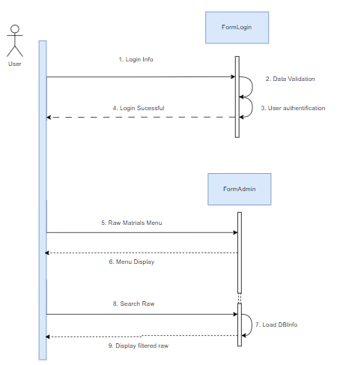

1. **Fulfill order from store with invoice creation**

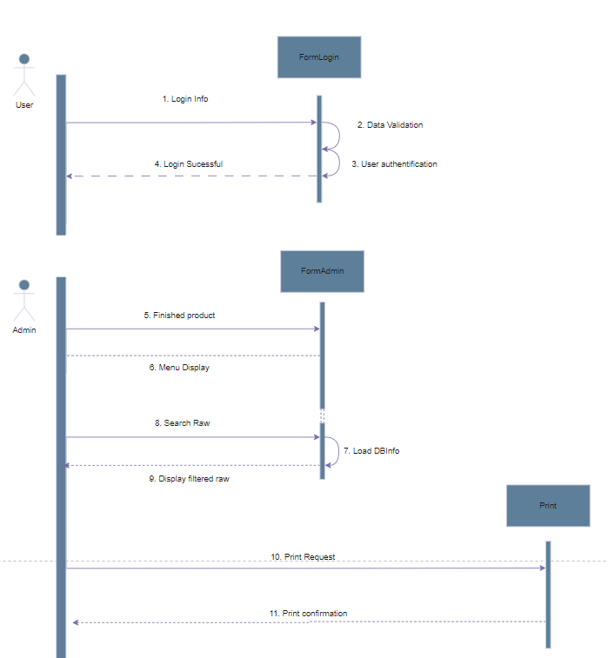

1. **DB export for data analysis**

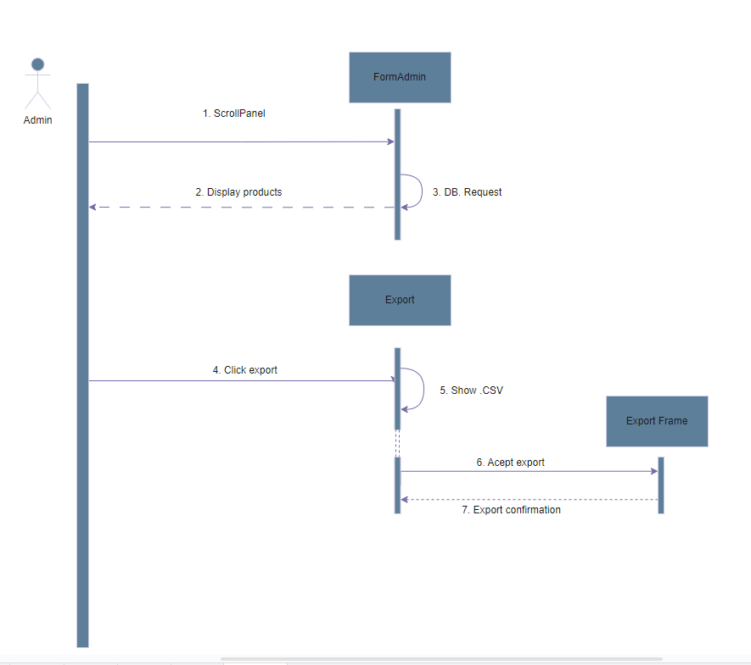

1. **HR adding a new employee**

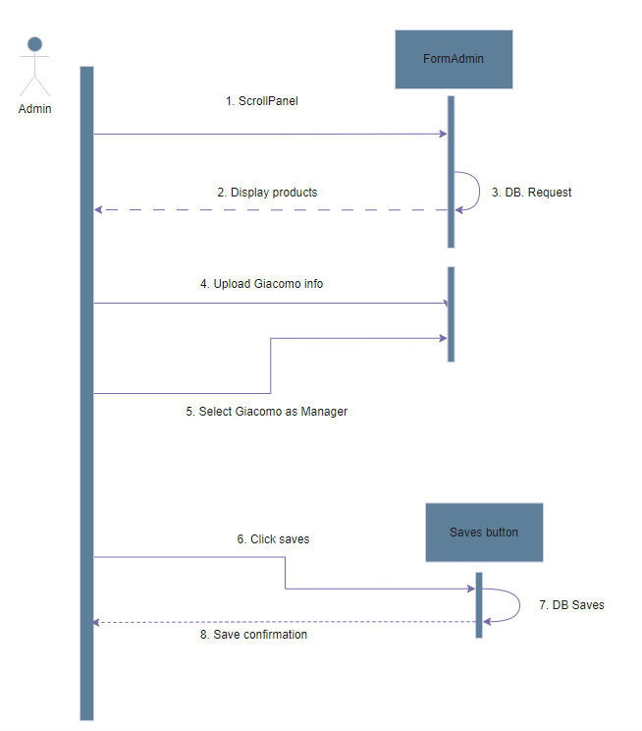

1. **HR changing employee data**

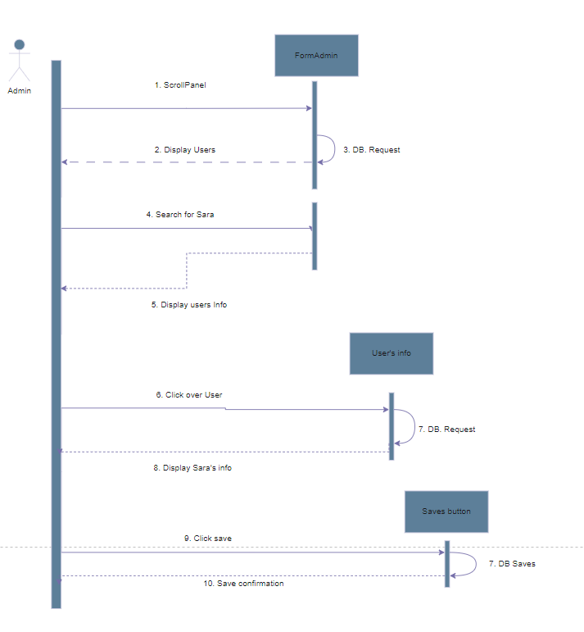

### 3.2.5 Mapping on Requirements

| **Use Case** | **Requirements** |
| --- | --- |
| Manager inspects current stock of raw material | R5 |
| Fulfill order from store with invoice creation | R5, R6, R7,R8 |
| DB export for data analysis | R9 |
| HR adding a new employee | R1, R3, |
| HR changing employee data | R2, R3, R4 |

## 3.3 Performance Requirements

The main concern of the system, as the LogiHR business is the one providing the SQL server service, is that the server side shall be always available. There is no need for low latency as the exchanged information is not heavy but it is recommended to keep multiple backup servers so that there is not a single point of failure in the system, as down-time may result in millionaire losses for the clients. Also it is recommended to schedule daily backups.

## 3.4 Design constraints

The program shall follow the standard protocols described in 3.1.3, mainly the standards regarding the TCP-IP and SMTP protocols. Also it shall follow the laws regarding security and privacy in the country in which it operates.

## 3.5 Software system attributes

### 3.5.1 Reliability

One of the most important aspects of the software is that it shall be reliable in its main job which is inventory management. Meaning that the code part regarding SQL query (specifically when changing database information) shall be impeccable to not change a parameter in the database that was not intended to be changed.

### 3.5.2 Availability

The availability must be kept at 100% during working hours, for this reason it is recommended to have multiple servers so that there is not one point of failure. Maintenance of the servers shall be done during night hours or holidays to not affect the clients.

### 3.5.3 Security

Due to the DB containing sensitive information regarding employees, security must be kept thigh. It is highly recommended that a private security firm reviews the code before launching the product to be sure there are no vulnerabilities in the code (for example SQL injection vulnerabilities).

# 4 DataBase Management.

## 4.1 Database Overview

The database used in this project is designed with simplicity in mind, yet it plays a crucial role in managing key aspects of the system. Its primary purpose is to efficiently store user information and provide a streamlined way to track both the company's human resources and inventory of raw materials and finished products. By organizing this data in a structured manner, the database facilitates smooth operations for administrators and warehouse managers.

The database is composed of four main tables, each serving a specific function within the system:

### 1. Admin_Info:

This table stores essential information about the administrators of the system. It includes:

* Username: The admin's unique identifier used for logging into the system.
* Password: A securely hashed password to ensure only authorized access.

This table allows for easy management of administrative credentials and serves as the foundation for user authentication within the system. Admins have access to the full suite of system functionalities, including employee management and product inventory control.

### 2. Manager_Info:

The Manager_Info table contains detailed records of all employees in the company. The key data fields include:

* Name: The full name of the employee.
* Gender: Information about the employee's gender (Male/Female).
* Address: The current residential address of the employee.
* Role: The role or job title of the employee (e.g., Manager, Clerk).
* Joining Date: The date the employee started working at the company.
* Salary: The employee’s current salary.
* Password: The manager's password for logging into the system.

Managers can modify this table to add new employees, update existing employee information, or remove records when employees leave the company. The flexibility of this table ensures that the company’s HR data is always up to date, providing admins and managers with a reliable resource for managing personnel.

### 3. RawMaterialInfo:

This table is responsible for tracking the raw materials used in the garment production process. The fields include:

* Raw Material Category: The type of raw material (e.g., fabrics, buttons, zippers).
* Product Name: The specific name of the raw material (e.g., Cotton, Silk).
* Quantity: The current stock level of the raw material.
* Cost: The total cost of the raw material in inventory.
* Received Date: The date when the raw material was added to the inventory.

This table is crucial for managing the supply chain, allowing the user to view, modify, or update the current inventory of raw materials. By keeping this information accurate, the company can ensure a steady production flow and avoid stock shortages.

### 4. FinishedProductInfo:

The FinishedProductInfo table holds data on the finished products that the company produces and sells. The key fields include:

* Finished Product Category: The category of the product (e.g., T-shirts, Jackets).
* Product Name: The name of the finished product (e.g., Basic T-shirt, Winter Jacket).
* Quantity: The number of finished products currently in stock.
* Cost: The production cost associated with the finished product.
* Manufacturing Date: The date when the product was manufactured and added to the inventory.

This table not only tracks inventory but also enables critical business functions. For example, users can generate invoices for sales transactions based on the data in this table. Additionally, the system can email invoices directly to clients or suppliers, streamlining the sales and distribution process. Accurate tracking of finished products ensures better inventory management and customer satisfaction.

By organizing data into these four core tables, the system efficiently balances simplicity with the ability to handle complex tasks, such as generating reports, managing inventory, and controlling user access. This database structure is integral to the overall functionality and success of the LogiHR system.

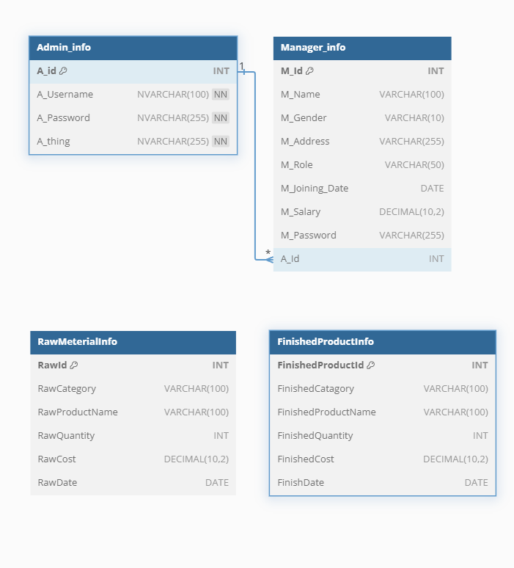

## 4.2 DataBase Instructions.

To create the DataBase it is possible to use the following SQL. code.

CREATE TABLE Admin_info (

A_id INT IDENTITY(1,1) PRIMARY KEY, -- Auto-increment ID for each admin

A_Username NVARCHAR(100) NOT NULL, -- Username of the admin

A_Password NVARCHAR(255) NOT NULL, -- Hashed password of the admin

A_thing NVARCHAR(255) NOT NULL,

);

CREATE TABLE Manager_info (

M_Id INT PRIMARY KEY, -- Employee/Manager ID

M_Name VARCHAR(100), -- Employee Name

M_Gender VARCHAR(10), -- Gender (Male/Female)

M_Address VARCHAR(255), -- Address of the employee

M_Role VARCHAR(50), -- Role (e.g., Manager, Admin)

M_Joining_Date DATE, -- Joining date of the employee

M_Salary DECIMAL(10, 2), -- Employee's salary

M_Password VARCHAR(255), -- Password for login

A_Id INT -- Admin ID who created the entry (Foreign Key from Admin_info)

);

CREATE TABLE RawMeterialInfo (

RawId INT PRIMARY KEY, -- Raw Material ID

RawCategory VARCHAR(100), -- Category of the raw material (e.g., Fabrics, Buttons)

RawProductName VARCHAR(100), -- Product Name of the raw material (e.g., Cotton, Jeans Buttons)

RawQuantity INT, -- Quantity of the raw material

RawCost DECIMAL(10, 2), -- Total cost of the raw material

RawDate DATE -- Date the raw material was received

);

CREATE TABLE FinishedProductInfo (

FinishedProductId INT PRIMARY KEY, -- Finished Product ID

FinishedCatagory VARCHAR(100), -- Category of the product (e.g., T-Shirts, Outerwears)

FinishedProductName VARCHAR(100), -- Name of the finished product (e.g., Basic T-shirt, Jacket)

FinishedQuantity INT, -- Quantity of the finished product

FinishedCost DECIMAL(10, 2), -- Cost of the finished product

FinishDate DATE -- Date when the product was manufactured

);

# 5 Effort Spent

Antonio Aslan

| **Task** | **Time (hours)** |
| --- | --- |
| SW development | 20 |
| Section 1 | 5 |
| Section 2 | 6 |
| Section 3 | 10 |
| Section 5 | 1 |
| **Total** | 42 |

Felipe Cano

| **Task** | **Time (hours)** |
| --- | --- |
| SW development | 27 |
| Section 1 | 3 |
| Section 2 | 12 |
| Section 3 | 2 |
| Section 5 | 1 |
| **Total** | 45 |

# 6 References

* [SQL Server Manual](https://learn.microsoft.com/en-us/sql/sql-server/?view=sql-server-ver16)
* [MySQL reference](https://dev.mysql.com/doc/refman/8.4/en/)
* Elicitation of requirements 2022-2023
* Slides from Software Engineering course 2022-2023